501 there can be only one start and one end which are ovalsrectangles are stsments and diamonds are decisones

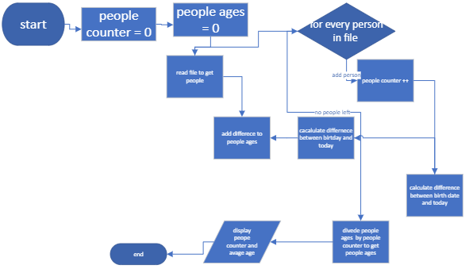

502 this is a flow chart i made



503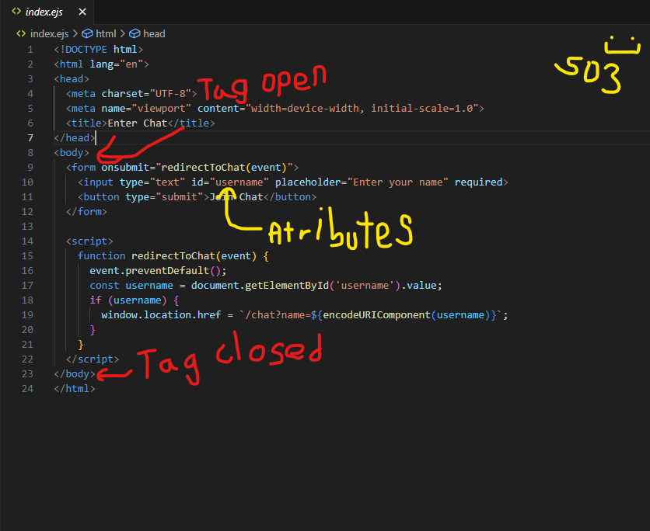

504

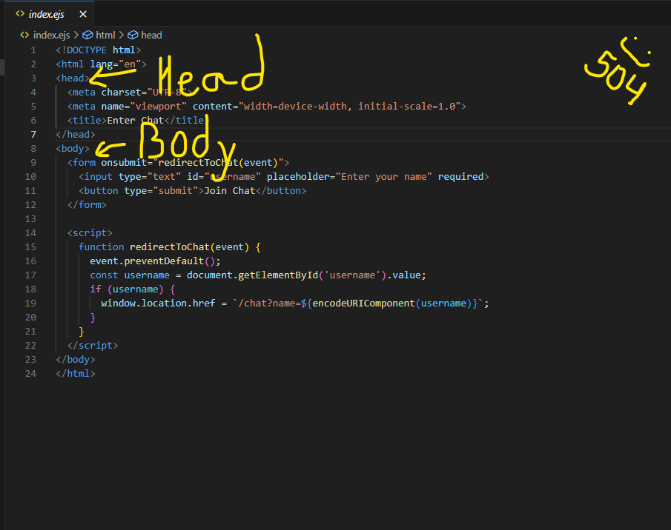

505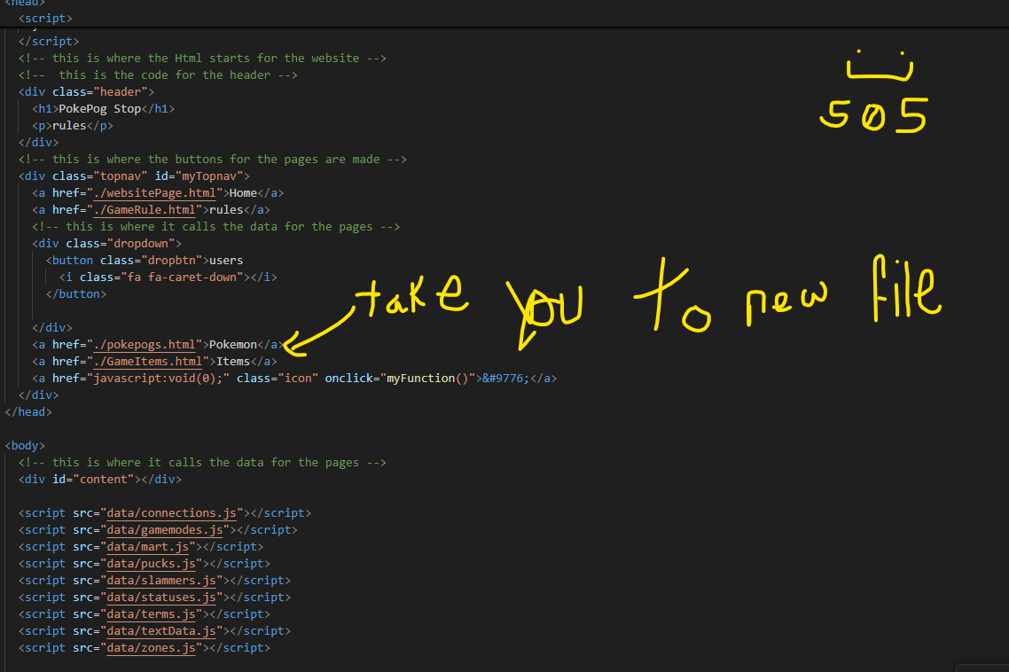

506

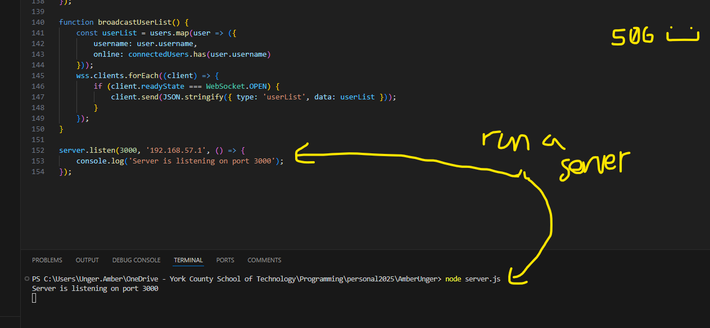

507

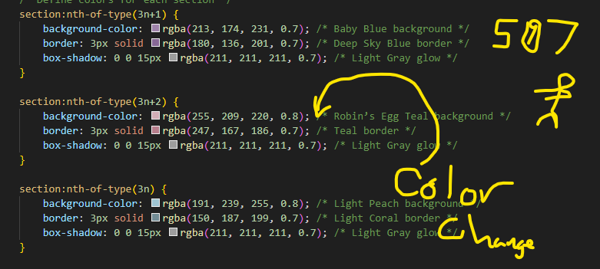

508

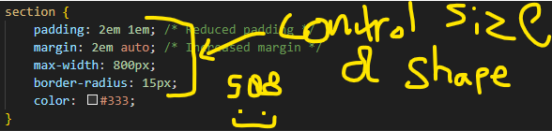

509

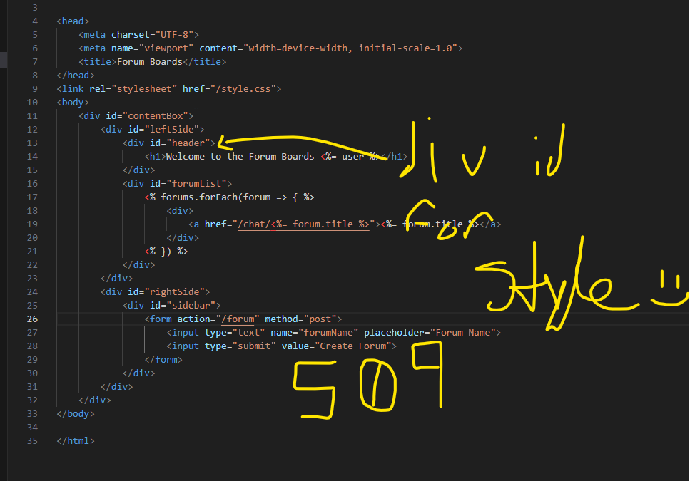

510

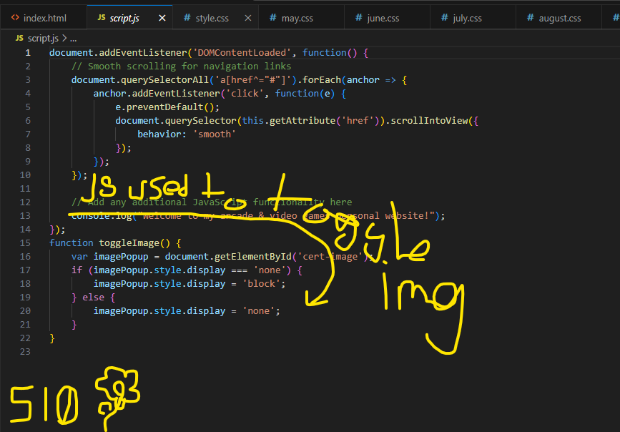

511

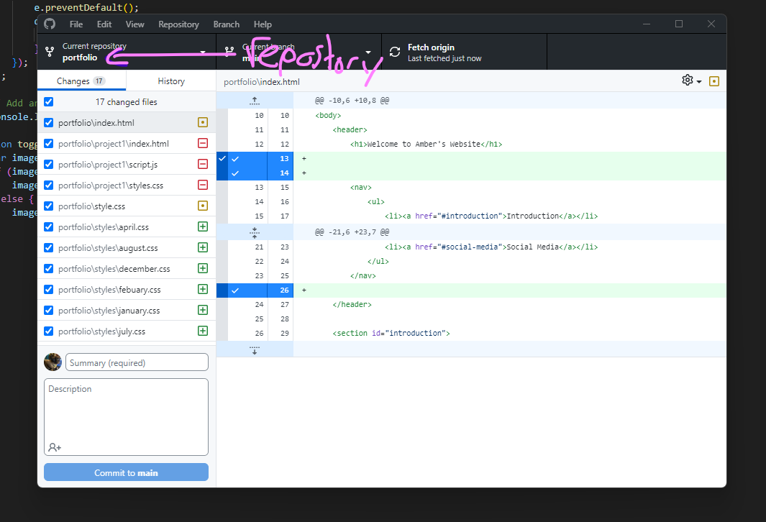

512

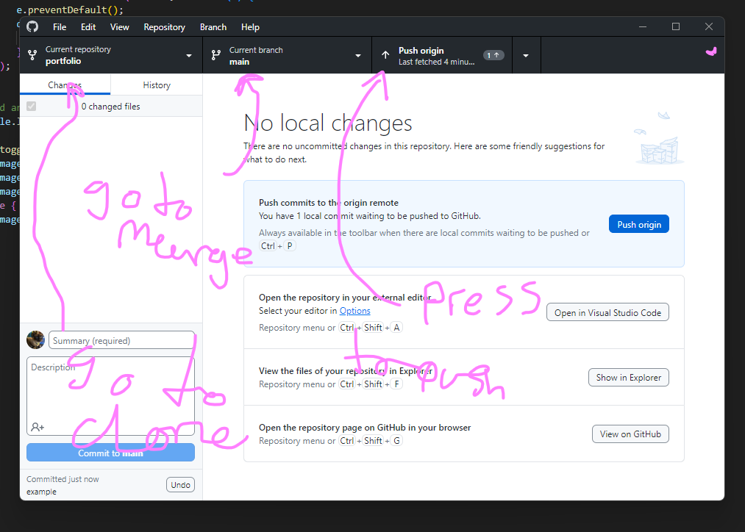

513

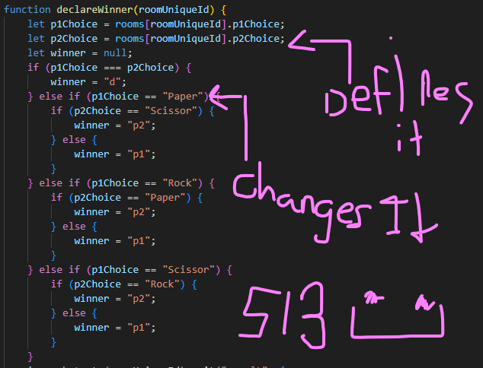

514

If this happens do that

Else if do this

Any thing else do that

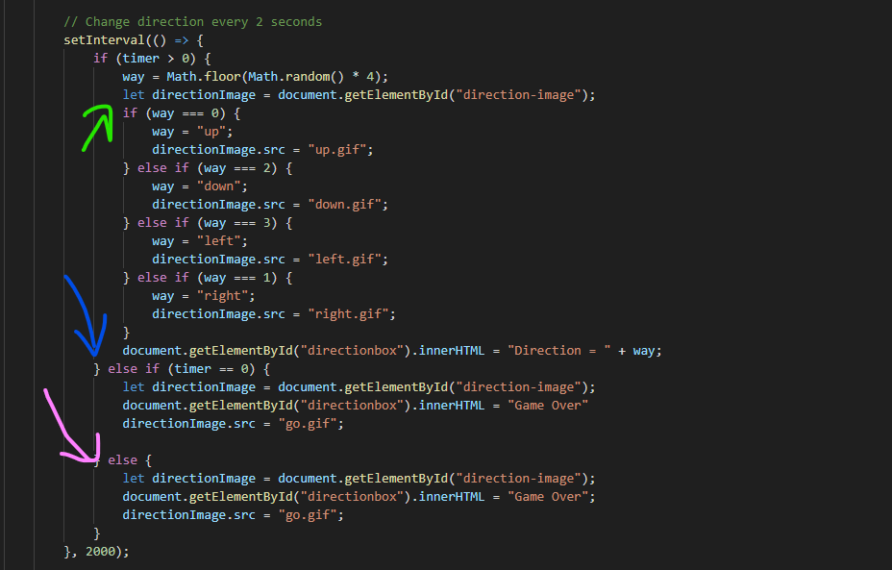

515

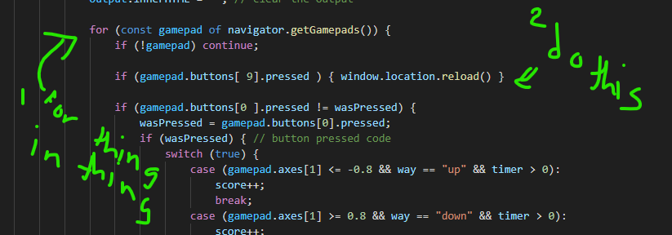

601

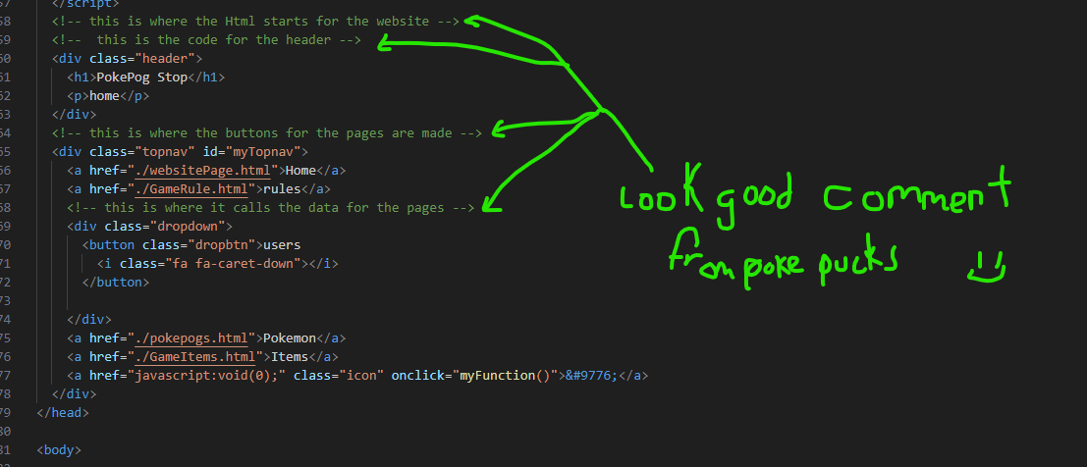

602

A boolean X = true or X = false

A integer X =1 ( or any other whole number)

A float x= -12 or x = 3.14159 (any number thats not a whole number)

And a string x = “hi” “no crotaines means its = to a variable like ( x = y ))

603

X = “hi”

Answers = User input = “25th of june”

Assigning the user input to the variable answers to save it

604

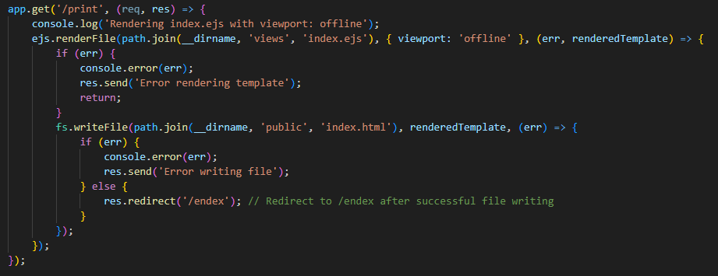

605

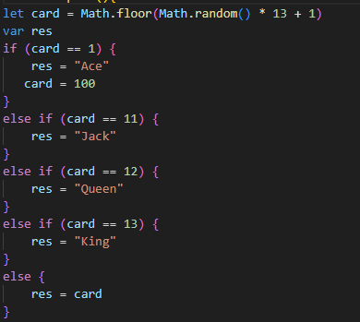

606

A for loops does something for each of something for example

For each question in test console.log (answers)

Unlike a while loop that does something when a condition is set for example

While day = true console.log (“you can only sleep at night”)

607

When this AND this is true do that

Then this OR this is true do that

When this is NOT true do that

608

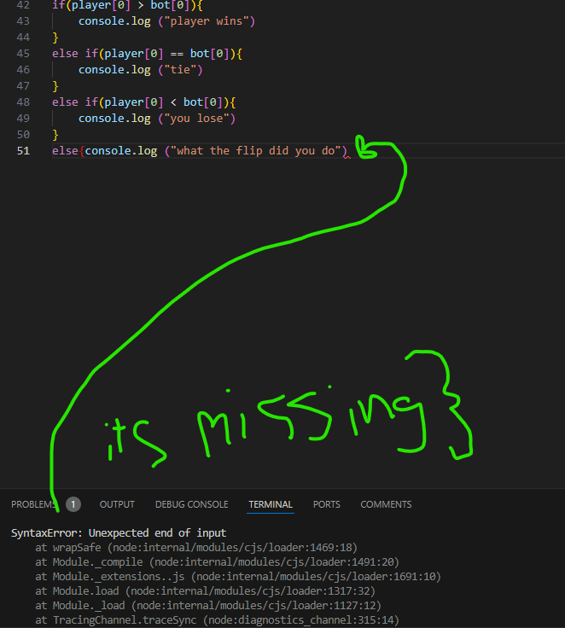

609

Opps i forgot this to late now (;

610

611

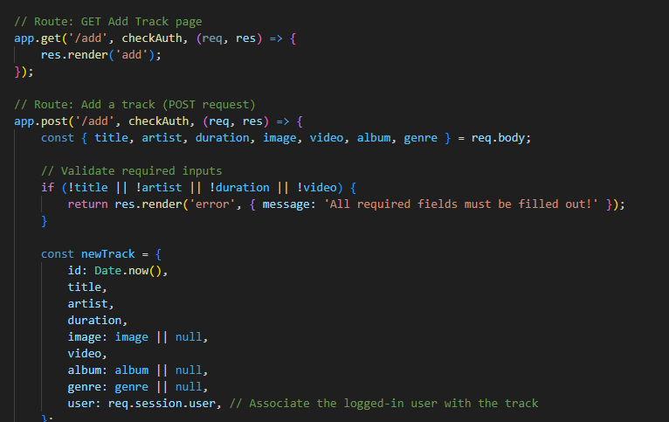

612

613

614

615